MINDFULNESS GRADING RUBRIC: MIDTERM
Categories
- Monday—Flow ___________/10
  - Completes sun salutations
  - Uses time to focus
- Tuesday—Video Participation ___________/10 Assessment (Demonstration)
10 | Mastery | 100% Correct
8 | Progressing | 80-99% Correct
6 | Needs Improvement | 70-89% Correct
4 | Area of Concern | 60-79% Correct
0 | Incomplete | 0-59% Correct
  - Active participation
  - Cooperation with others
- Wednesday—Grounding Poses ___________/10
  - Identifies and demonstrates poses
- Thursday—Video Focus ___________/10
  - Stays on task
  - Does not disrupt others
  - Is not disrupted by others
- Friday—Discussion/Presentation of Activity ___________/10
  - Participates in discussion/presentation
  - Makes connections between content and experiences
Choose One of the Following: ___________/50

- Write a letter to the editor, principal, or superintendent about the importance of a mindfulness class for physical AND mental well-being. The letter must include research as to why mindfulness is important for physical and mental health. The letter must be at least 5 paragraphs and grammatically correct.
50 | Mastery | 100% Correct
40 | Progressing | 80-99% Correct
30 | Needs Improvement | 70-89% Correct
20 | Area of Concern | 60-79% Correct
0 | Incomplete | 0-59% Correct
- Choose 10 yoga poses with a focus being on grounding poses. Take pictures of yourself doing them and write a summary of each pose. Print out an 8x11½ page picture and put the title of the pose on it. You will glue it to construction paper and put the explanation of the poses on the back of the paper. The poses should be done correctly, explained correctly, and you will be graded on the creativity of where the pictures were taken. You will also record yourself reading a scripted meditation that is 5-10 minutes in length, upload it to youtube with a picture in the background. Points will be on reading accuracy, pacing, and background music.
- Create a 10-20 minute yoga routine. Tape yourself leading it and upload it to youtube. You will be graded on time and accuracy of poses. It can be a relaxing yoga video but must include at least 10 poses.
Assessment (Project)

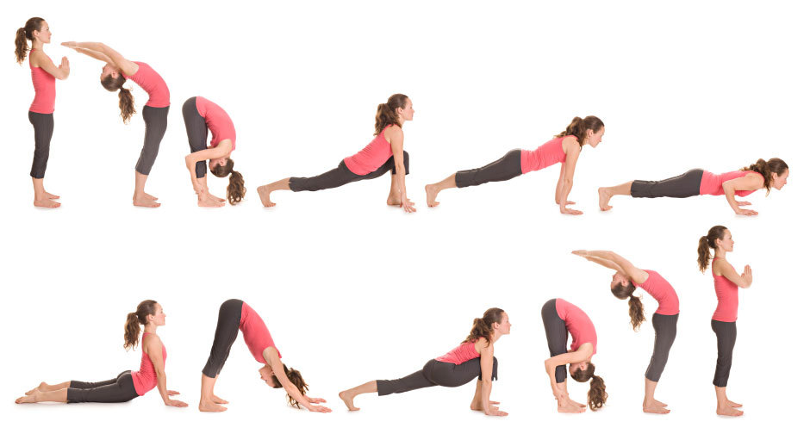
Sun Salutation Sequence: https://www.youtube.com/watch?v=73sjOu0g58M&index=22&t=348s&list=PLeB8Qy7Rq93qXYg8KLhYKC4VJ1Sqmb3_n

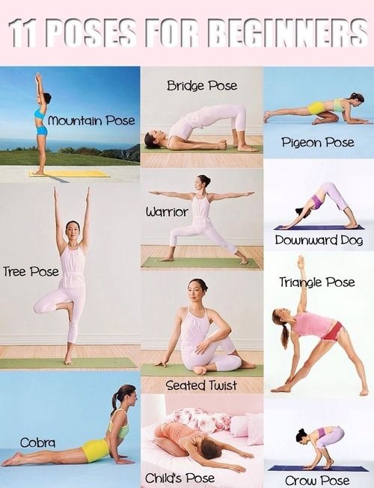

Grounding Poses You Need to Know
(all but crow pose):

